1. Open Gitlab
2. Create New Project
3. Create a New File in it
4. Type .gitlab-ci.yml as FileName
5. 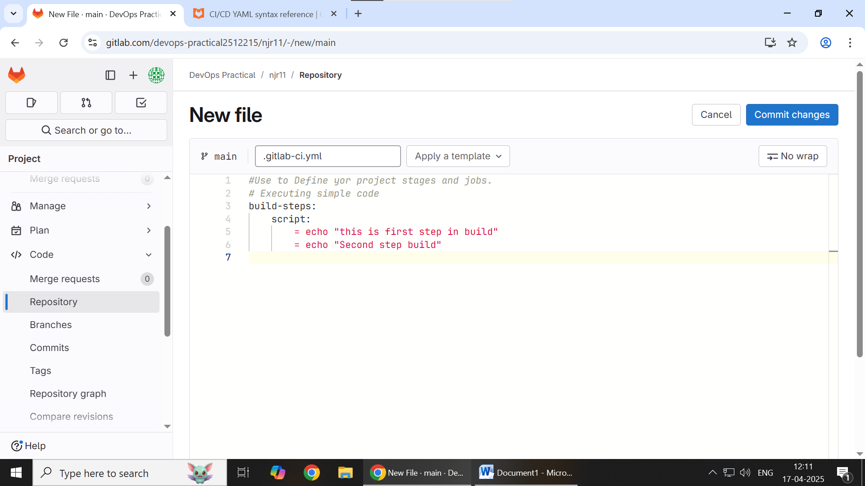
6. Then click on Commit changes
7. Type any commit message in it
8. 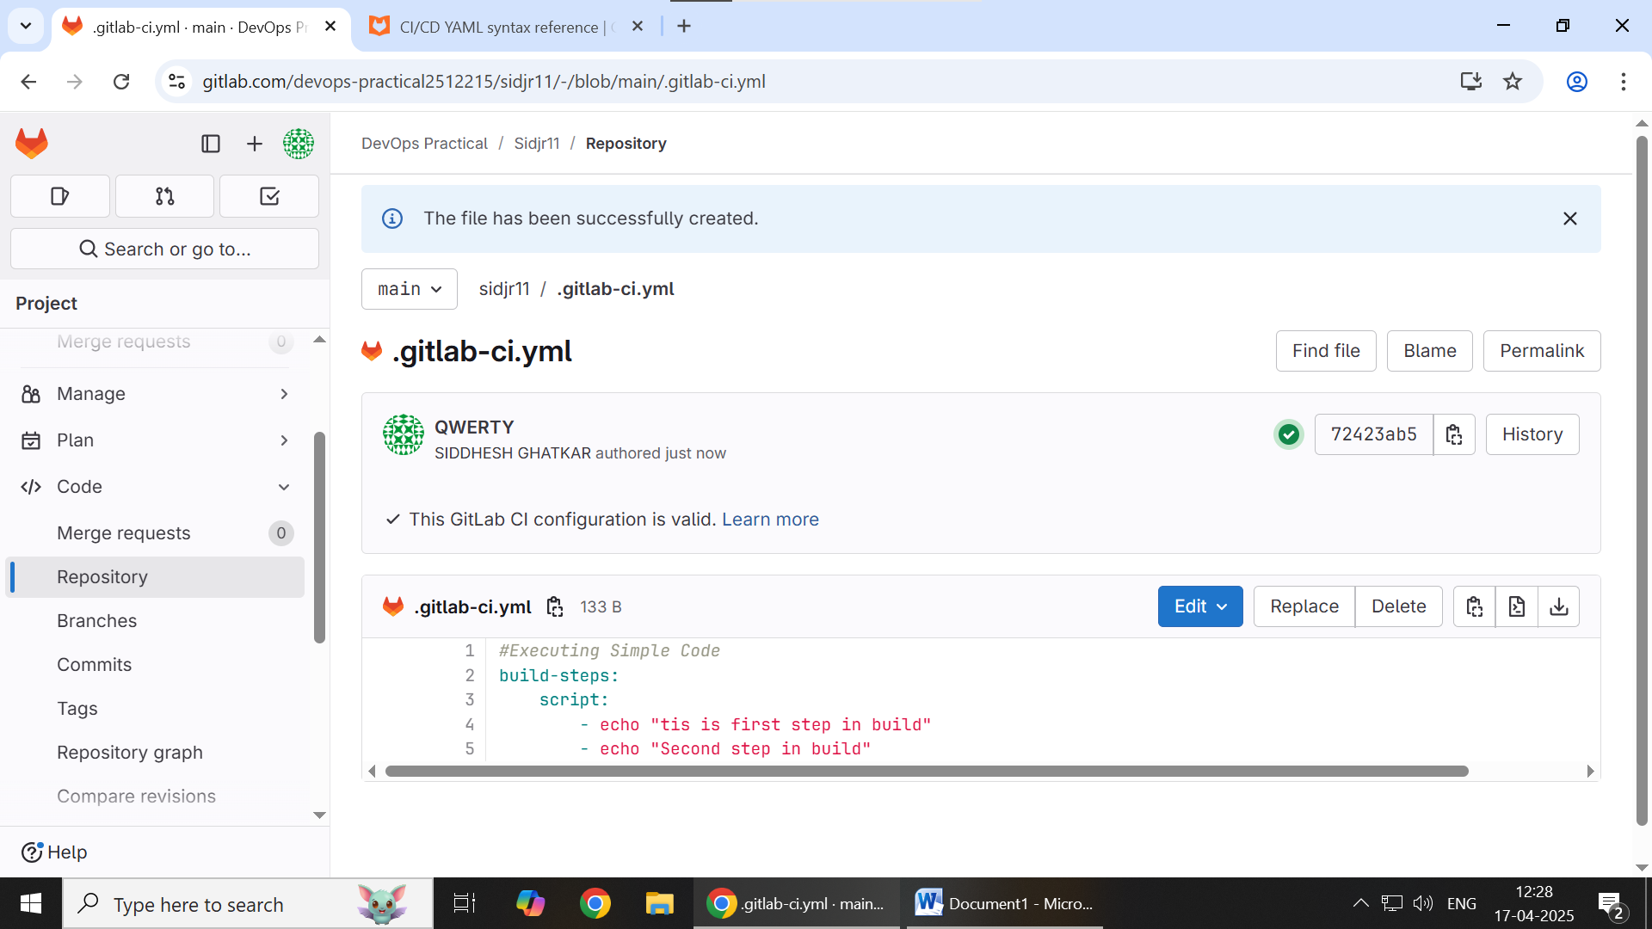
9. Change is commited

Executing all the 3 stages:

1. Create a new project
2. Create a New file in it
3. Type .gitlab-ci.yml as FileName
4. 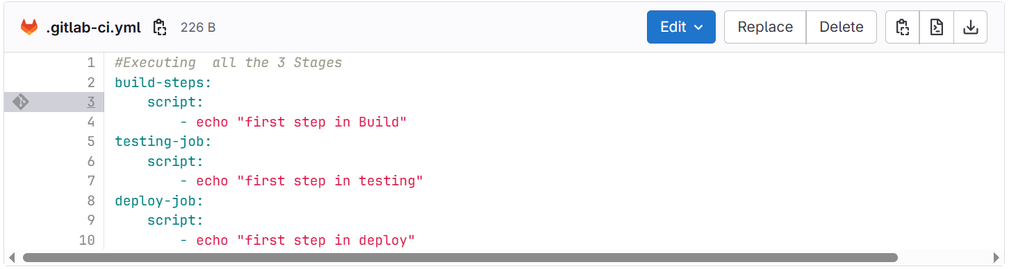
5. Click on Commit change
6. 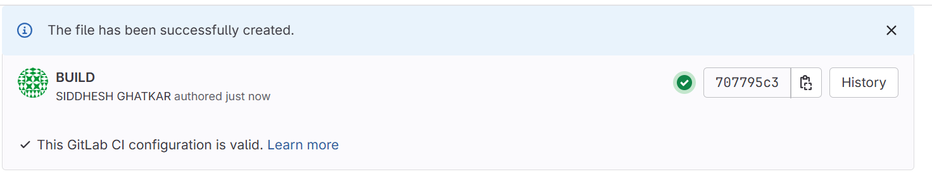
7. Click on Tick (Green)
8. 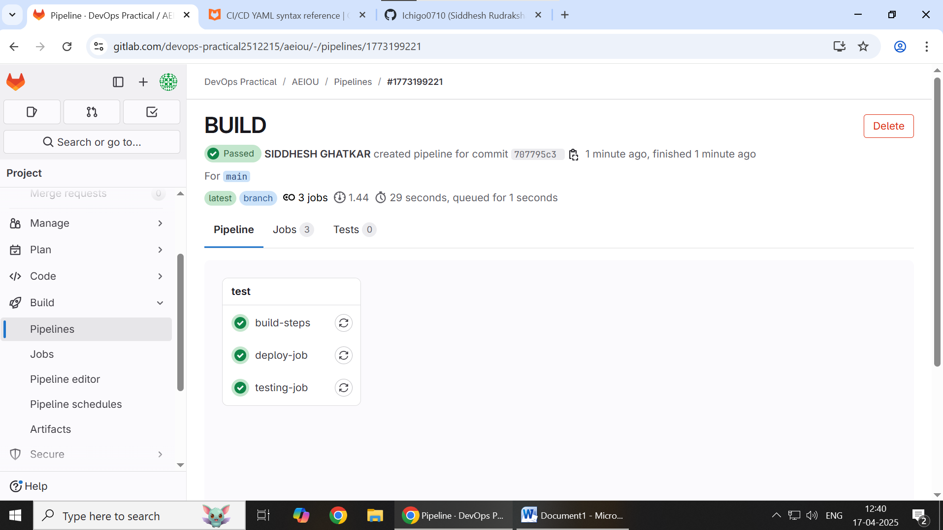

Shell Demo

1. Create a New Project
2. Create a (Config) New File
3. 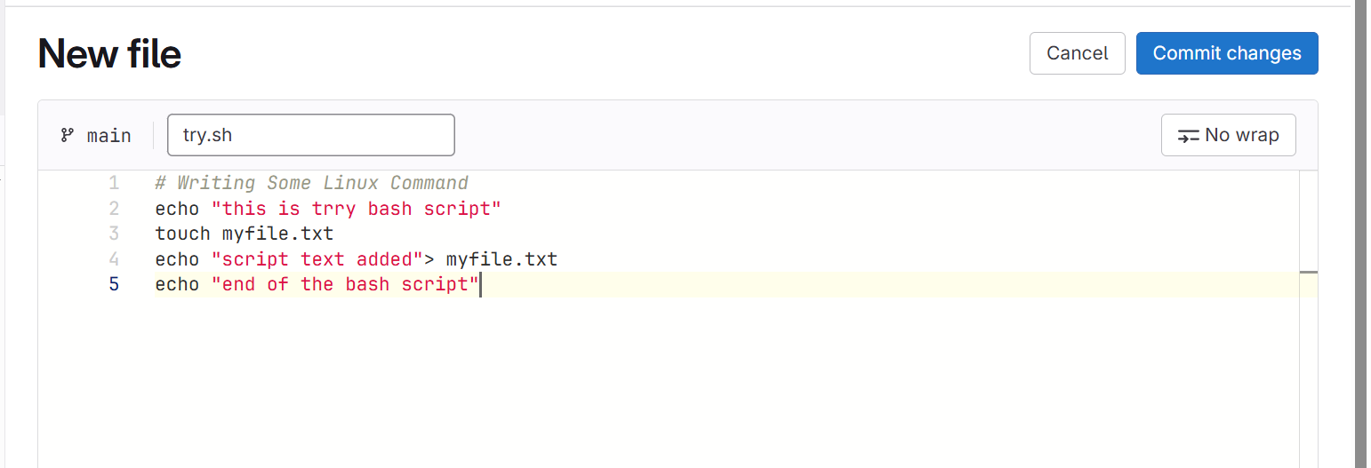
4. Click on Commit Changes
5. 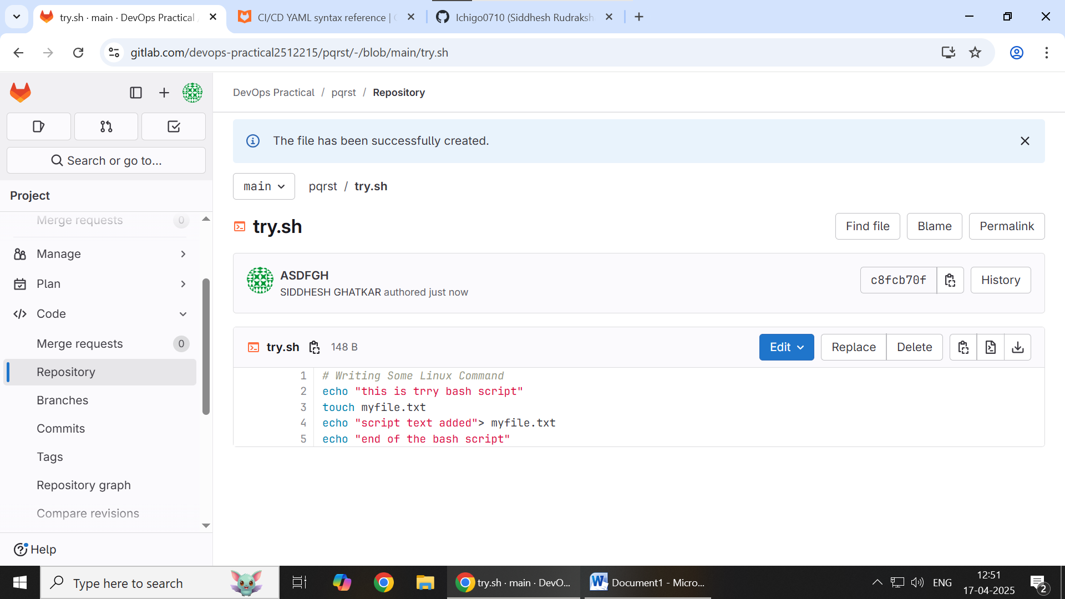
6. Create a new file in same project
7. 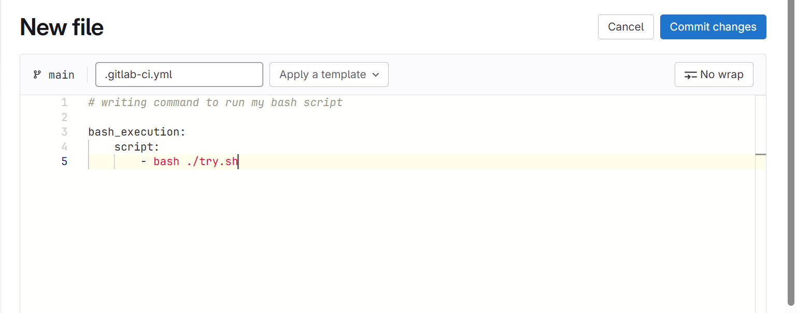
8. Commit changes
9. 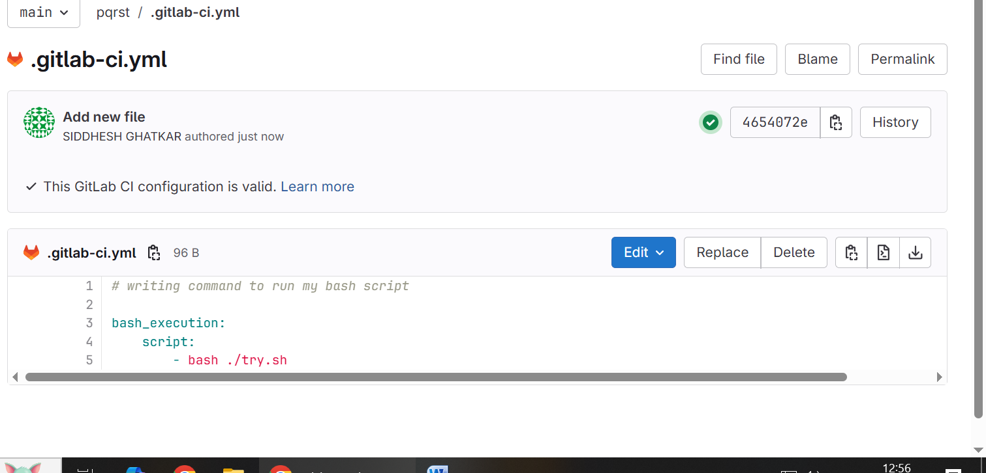
10. Click on Green tick
11. 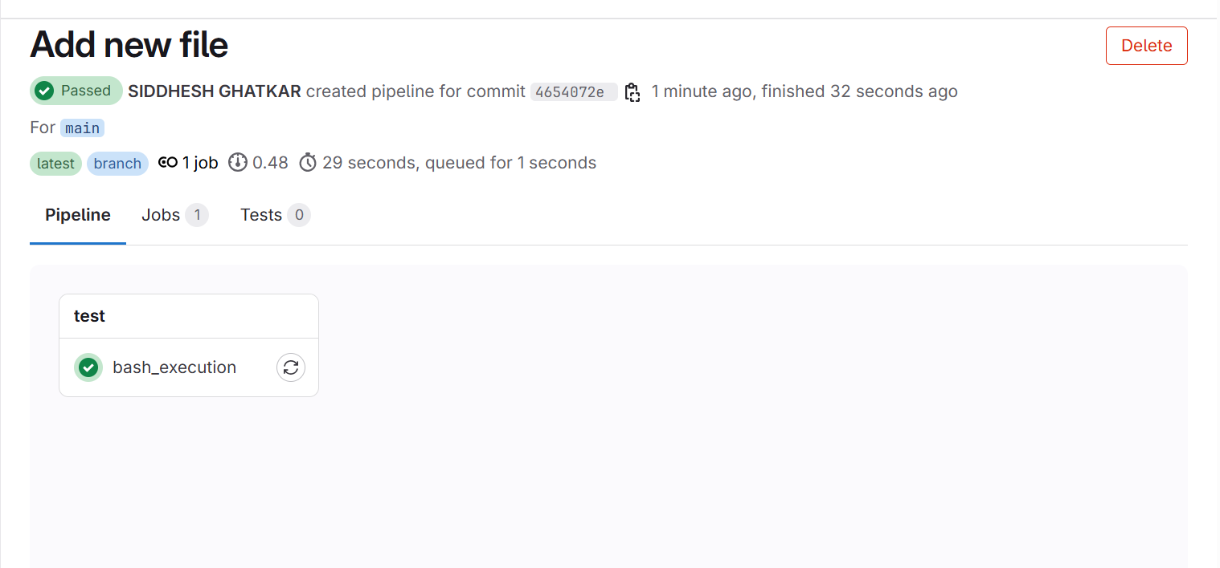
12. Click on green tick of bash_execution
13. 